Variance observation report

The exact final variance observed by the given data is 8283502.777600

The following was observed on using different methods for calculating variance upto the present data:
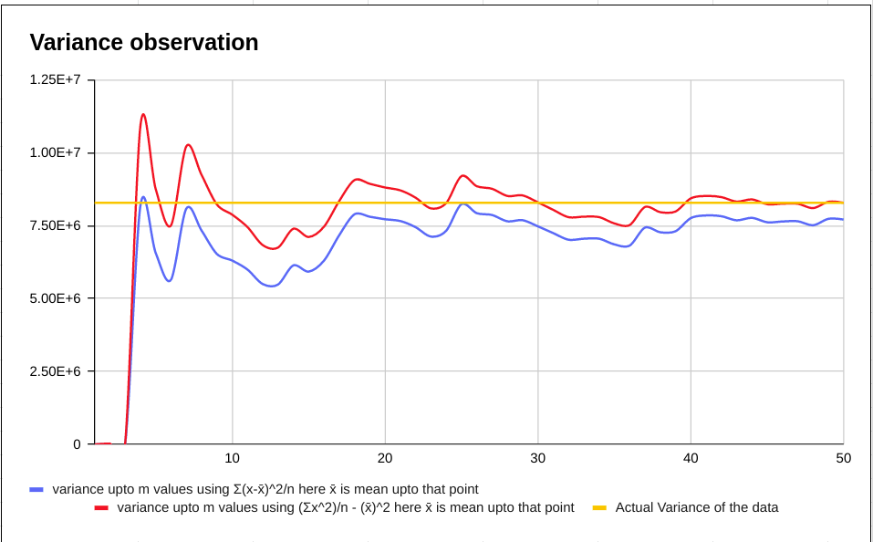
the variance slowly converges to the actual variance as we read more and more data

link to the database
https://docs.google.com/spreadsheets/d/1OuoRCmSsDuqSGULmUGL62gR1daqz7HshSVD9PT-1CmY/edit?usp=sharing

link to the C code to find approximate variance:
https://drive.google.com/file/d/14mFhdQrOI1WUsbxDuPjVD64jTzPA85O_/view?usp=sharing

